Exercise 1-3

Note for the plots: The y-axis is for the velocity u and the x-axis is for space dimension x. Time is the time step (The function running period). $c_{f}$ is the Courant factor.

Burger’s Equation $\frac{du}{dt}+u\frac{du}{dx}=0 , x∈[0,10]$

Initial data: $u\left(x,t=0\right)=10*{e^{-{\left(x-x_{0}\right)}^{2}}{ }}^{ }$

The initial data develop shock and rarefaction wave in both cases (Conservative and Non-Conservative Flux, CF and NCF respectively).

CF: $u_{j}^{n+1}=u_{j}^{n}-\frac{∆t}{∆x}[f_{j}^{n}-f_{j-1}^{n}]$ NCF: $u_{j}^{n+1}=u_{j}^{n}-\frac{∆t}{∆x}u_{j}^{n}[u_{j}^{n}-u_{j-1}^{n}]$

For the Flux Conservative form, I got these results (Figure 1):

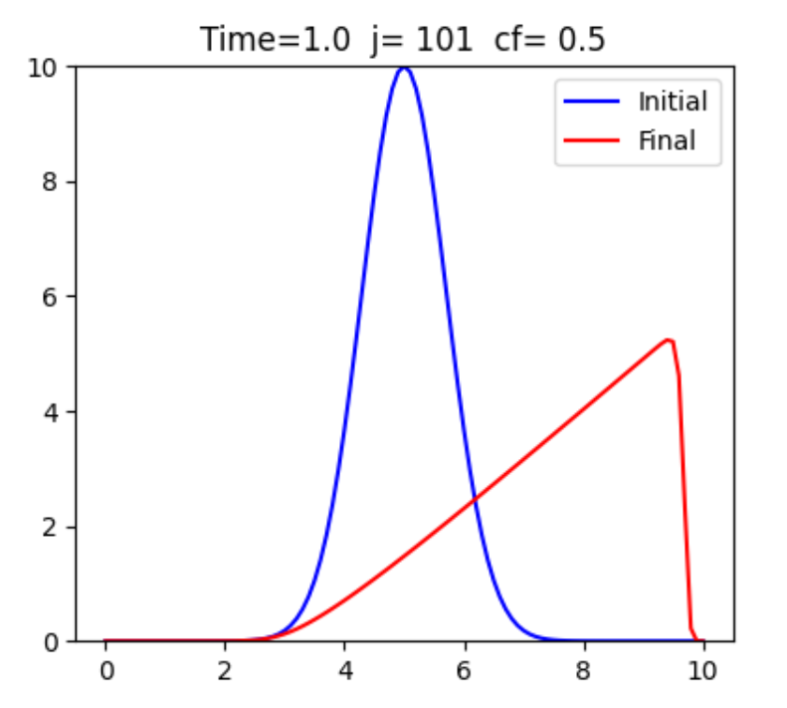

**Figure 1: The blue line is the plot for the initial data while the red is for the initial data after a time step (Time = 1).**

1- If a is less than 10 the method will be unstable due to the CFL. 10 is the maximum value of the function of the initial data.

2- Increasing the resolution will increase the sharpness of the shock (Compare Figure 1 to Figure 2). But at some point, increasing j does not produce visible change (Figure 2).

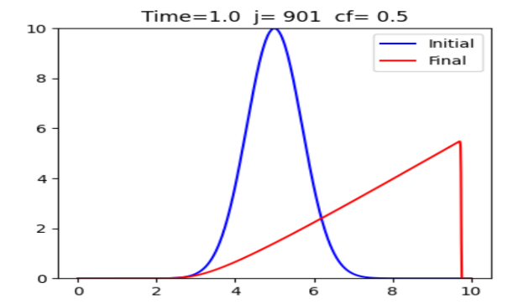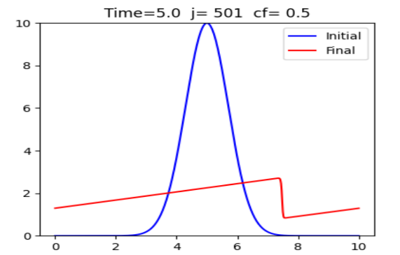

**Figure 2:** Plot for CF with evolution time=1 **Figure 3:** Plot for CF with evolution time=5

3- The shock maximum value depends on “Time”. Increasing the code run time step $∆t$, will make dissipation in the shock more and more (The maximum value of the shock will be less). Compare Figure 2 and Figure 3.

4- Both forms CF and NCF act the same under changing the resolution and the time of evolution. The difference is that in NCF gives the wrong solution for the equation as expected from Hou-le Flock Theorem while CF gives the right solution as expected from Lax-Wendroff Theorem. The NCF creates a shock at a different position on the x-axis. (see figure 4)

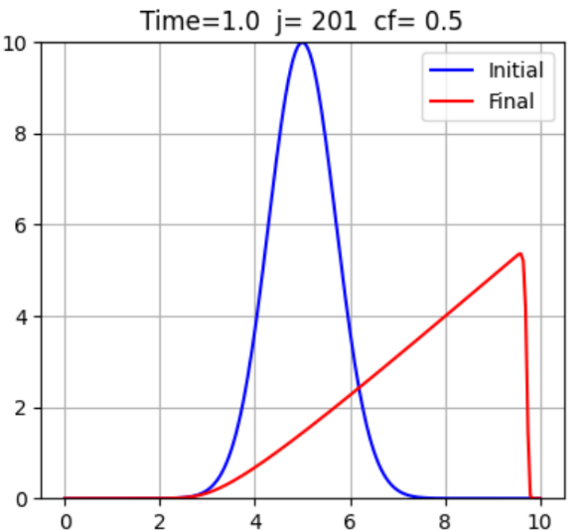**Figure 4:** The solution for the CF is on the left and for NCF is on the right.

